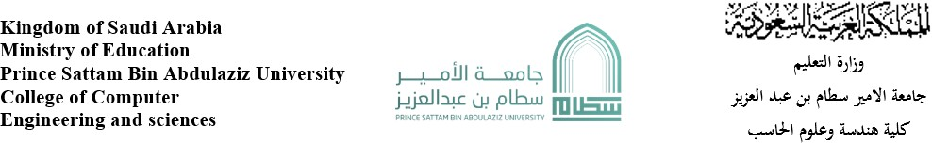

Search about:

Nafes website

Abdullah alsheddi 443051124

Supervised by : Mohammed Assiri

Year : 2023

Q1

1-The purpose of the website is to gather the gamers.

2-the services provided by this website is a tournaments for some games and this website is the link between the gamer and the Saudi Esports .

3- www.nafes.com

Q2

1- the category is games and yes it’s obvious because the home page is all about games and some news about it .

2- in my opinion yes the design accomplishing the purpose of the website and that’s clear enough.

3- The target audience is professional players and the design on this site attracts and encourages them by placing pictures and news of the most professional Saudi players in the Esports.

Q3

1-The load time is 1.51 s (the test was taken from Europe) , 1.5 second is a good time but not the best but I think it’s still a good time.

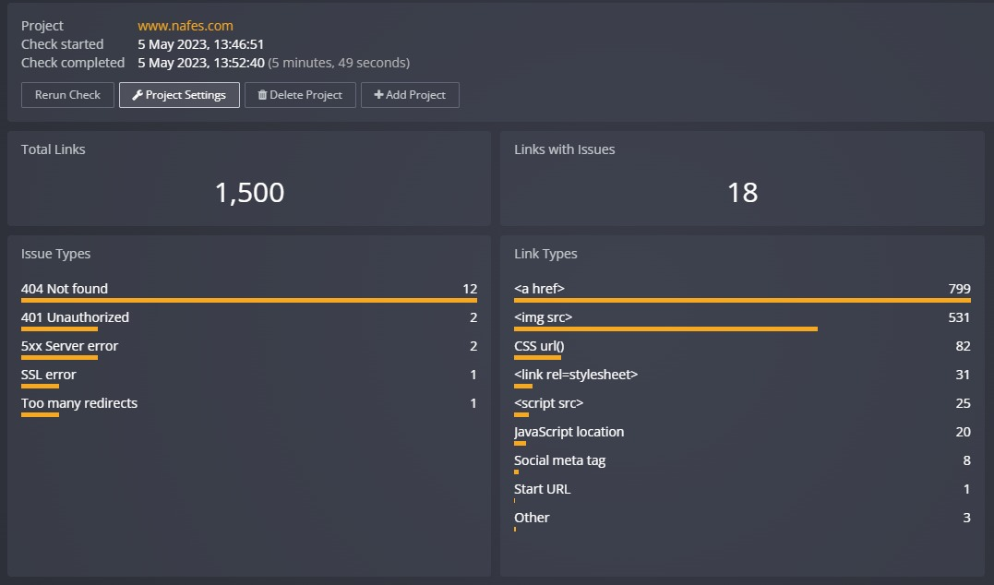

2- yes it’s .

3- yes there is a search button available for visitors but it’s not good enough.

4- No it’s not, the percentage of the Links with issues is 1.2% .

5- it’s works in all browsers.

6- it’s works in mobile browsers also.

Q4

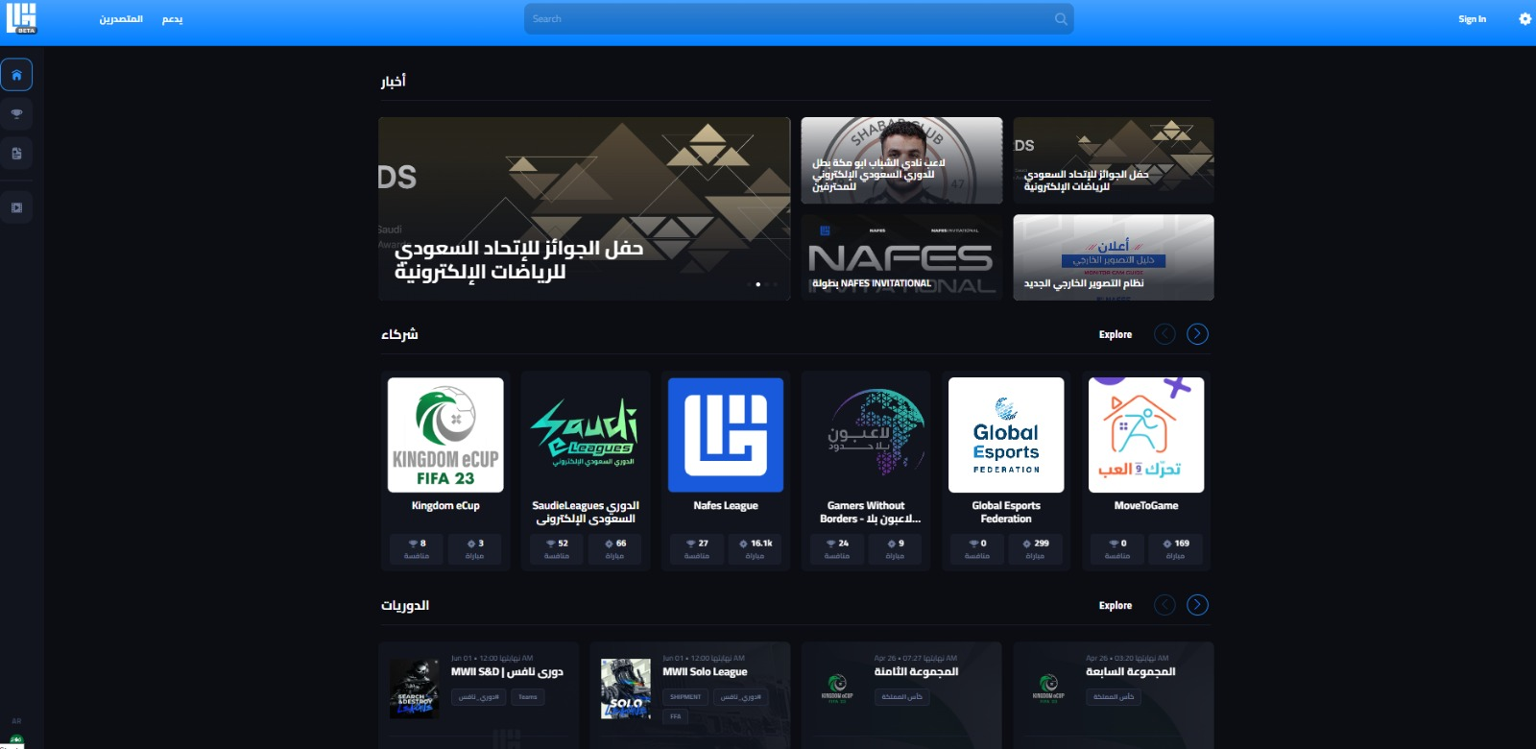

1- it’s easy for me and i think it’s also easy for most of users.

2- yes , the background colour is black and the front colour is white so it’s clear.

3- I think in the rules the front should be bigger.

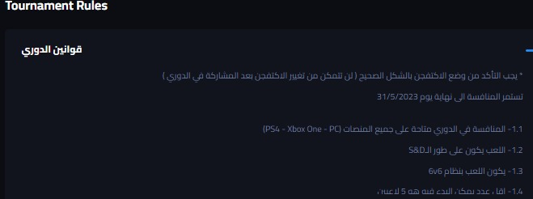

4- yes the contact still useful and they add a tournaments or leagues every month.

Q5

The website for gamer and its encourages them to be pro players and make money from the game they play, most of families here in Saudi Arabia have a son who loves games and plays a lot.

I recommend families teach this boy this site and take advantage of his free time and perhaps his talent,

and I recommend the website programmer to check the links that have some issues and fix it.

And the load speed can be faster so I recommend to find a way to make it faster.